Matthew Jang

Laika BOSS: Scalable File-Centric Malware Analysis and Intrusion Detection System

1. Introduction:

Threat actors often use the most common, critical protocols
such as email, web, and social media as delivery vectors, and target widespread and critical applications.

To defeat intrusions, defenders must be able to detect malicious files
wherever they exist - either transiting a network or stored on disk.

There are a multitude of malware analysis tools and reverse engineering resources available to analyze malicious code, but these tools work best in one-off, isolated conditions and are not capable of real-time processing.

Most intrusion detection systems are focused primarily on the medium they monitor (e.g. networkbased, host-based) --> aka medium-centric.

A modular approach to file analysis enables such an understanding. We propose a filecentric intrusion detection approach, allowing connectors to various network and endpoint devices which can disassociate the medium and any file encapsulation. A file-centric intrusion detection system, therefore, will scalably interpret, parse, and normalize files to expose malicious characteristics.

Each step of this analysis is done by its own self-contained module. This ensures that the tool never tries to eat the proverbial elephant all in one bite. What's unique about this approach is each module only has to do one thing.

To illustrate, if a virus was a house, YARA would attempt to take the entire house and break it down all at once. But what LaikaBoss attepts to do is to section the house into many different parts and use different tools (modules) to take down each unique part of the house. Each tool is made for a specific purpose.

2. Related Work:

YARA
- Standard signature string method
- Just a standalone scanning language
Viper
Cuckoo Sandbox

3. Approach

Laika implements the core functionality of
dispatching input files to modules that typically perform extraction of subfiles, metadata collection, and/or detections such as signature matching.

The recursive, module-based Laika framework is written in Python and YARA and is easily extensible.

4. Design

In designing Laika, we identified three high level goals: scalability, flexibility, and transparency.

Scalability in Laika means processing huge volumes of files, or objects, from a variety of sources.

Synchronous Interface: is useful for clients that are in-line with delivery of a payload such as a Milter or an ICAP server.

Asynchronous Interface: is useful for clients handling a high volume of data that do not require immediate feedback such as a passive network sensor or analyst submission.

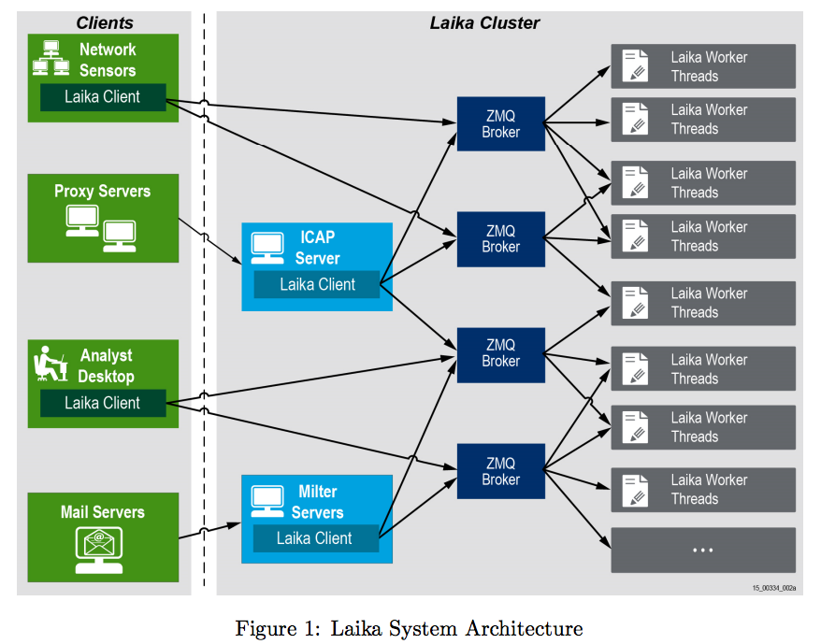

Modules are written in Python and executed based on dispatching logic written in YARA.

The dispatcher controls when and how a module runs, enabling specific content to run when needed and limiting the amount of unnecessary processing. This happens in two separate passes, enabling chained module execution.

Dispatcher instructions are provided through a collection of YARA rules that leverage free-form meta fields and external variables populated by the Laika framework.

